**Semester 1 (Unit 3) Examination, 2020**

**Question/Answer Booklet**

**MATHEMATICS APPLICATIONS**

**Section Two: Calculator-assumed**

Student Name/Number: ______________________________________________

Teacher Name: ______________________________________________

**Time allowed for this section**

Reading time before commencing work: ten minutes

Working time for this section: one hundred minutes

**Materials required/recommended for this section**

**To be provided by the supervisor:** This Question/Answer Booklet

Formula Sheet (retained from Section One)

**To be provided by the candidate:**

Standard items: pens (blue/black preferred), pencils (including coloured), sharpener,

correction fluid/tape, eraser, ruler, highlighters

Special items: drawing instruments, templates, notes on 2 unfolded sheets of A4 paper, and up to three calculators approved for use in the WACE examinations

**Important note to candidates**

No other items may be taken into the examination room. It is **your** responsibility to ensure that you do not have any unauthorised notes or other items of a non-personal nature in the examination room. If you have any unauthorised material with you, hand it to the supervisor **before** reading any further.

**Structure of this paper**

|  |  |  |  |  |  |
| --- | --- | --- | --- | --- | --- |
| Section | Number of questions available | Number of questions to be answered | Working time (minutes) | Marks available | Percentage of exam |
| Section One: Calculator-free | 6 | 6 | 50 | 50 | 35 |
| Section Two: Calculator-assumed | 11 | 11 | 100 | 104 | 65 |
|  | | | | | 100 |

**Instructions to candidates**

1. The rules for the conduct of School exams are detailed in the School/College assessment policy. Sitting this examination implies that you agree to abide by these rules.
2. Write your answers in this Question/Answer booklet preferably using a blue/black pen. Do not use erasable or gel pens.
3. You must be careful to confine your answer to the specific question asked and to follow any instructions that are specified to a particular question.
4. Show all your working clearly. Your working should be in sufficient detail to allow your answers to be checked readily and for marks to be awarded for reasoning. Incorrect answers given without supporting reasoning cannot be allocated any marks. For any question or part question worth more than two marks, valid working or justification is required to receive full marks. If you repeat any question, ensure that you cancel the answer you do not wish to have marked.
5. It is recommended that you do not use pencil, except in diagrams.
6. Supplementary pages for planning/continuing your answers to questions are provided at the end of this Question/Answer booklet. If you use these pages to continue an answer, indicate at the original answer where the answer is continued, i.e. give the page number.
7. The Formula sheet is not to be handed in with your Question/Answer booklet.

**Section Two: Calculator-assumed 65% (104 Marks)**

This section has **12** questions. Answer **all** questions. Write your answers in the spaces provided.

Supplementary pages for the use of planning/continuing your answer to a question have been provided at the end of this Question/Answer booklet. If you use these pages to continue an answer, indicate at the original answer where the answer is continued, i.e. give the page number.

Suggested working time: 100minutes.

**Question 7 (4 marks)**

At the birth of their first child, Mark and Julie set up an investment account for the future benefit of their children. They made an initial deposit of $1000 and they negotiated a long-term interest rate 2.6% pa. Each year, on the anniversary of the initial deposit, they added another $1000 to the account,

1. In which year was the account balance more than $10 000? State the balance for year just before. (2 marks)

On the 18th anniversary of the initial deposit they withdrew $15000 to purchase a vehicle for their oldest child. The account continues to accrue interest, and Mark and Julie continue to make the annual deposits up until, but not including the 25th year.

1. How much would there be in the account on the 25th anniversary of the initial deposit?

(2 marks)

**Question 8 (10 marks)**

1. A geometric sequence has and , determine the first four terms.

(3 marks)

1. A sequence is given by  and , determine the first four terms.

(3 marks)

1. James designed a walking exercise program. On day one he walked 2.8 km and on day two, he walked 3.0 km. His plan is to increase his walking distance on each subsequent day, by the same percentage increase, as over the first two days. (4 marks)
2. Complete the table of values below (to the nearest metre) to represent his daily walking distance over the first 6 days of his planned program.

|  |  |  |  |  |  |  |
| --- | --- | --- | --- | --- | --- | --- |
| *n* | 1 | 2 | 3 | 4 | 5 | 6 |
| Walking distance |  |  |  |  |  |  |

1. If he sticks to the program, on which day of the program will James first walk more than twice the distance he walked on day one.

**Question 9 (10 marks)**

The Royal Life Saving Society of Australia publishes annual reports of Aquatic Centres across Australia. Throughout the reports Western Australia is divided into two areas – Metropolitan and Regional.

Aquatic Centres are categorised as

|  |  |
| --- | --- |
| Type 1 | Predominantly lap‐swimming pools |
| Type 2 | Have both a lap pool and leisure pool |
| Type 3 | Have multiple lap pools and/or leisure pools |

Western Australian data were obtained for the year July 2012 – June 2013.

(a) The table below shows the representation of children in the Population of Western Australia and as Patrons (users) of Aquatic Centres.

|  |  |  |  |
| --- | --- | --- | --- |
|  | | Percentage Representation of Children | |
| Population of Western Australia | Patrons of Aquatic Centres |
| Area | Metropolitan | 26% | 28% |
| Regional | 27% | 52% |

(i) State the explanatory variable in this situation. (1 mark)

(ii) Describe the association that can be identified in the table. (2 marks)

(iii) Explain clearly a possible reason for the observed association. (1 mark)

(b) The following data shows the Costs Incurred per Patron by the Facility across different Areas and categories of Aquatic Centres.

|  |  |  |  |
| --- | --- | --- | --- |
|  |  | Costs Incurred Per Patron by the Facility | |
| Area | Regional | Type 1 | $82 |
| Type 2 | $40 |
| Type 3 | $11 |
| Metropolitan | Type 1 | $15 |
| Type 2 | $12 |
| Type 3 | $9 |

The incomplete table below shows the Percentage of Total Costs per Patron within each area.

|  |  |  |  |
| --- | --- | --- | --- |
|  | Type 1 | Type 2 | Type 3 |
| Regional |  |  | 8% |
| Metropolitan | 42% | 33% |  |

(i) Show how the 33% was calculated. (2 marks)

(ii) Complete the table. (2 marks)

(iii) Use the data to determine one association between the variables. Describe the association in the context of the question and explain your reasoning. (2 marks)

**Question 10 (14 marks)**

1. The network of an airlines routes between different cities is displayed in the graph below, where each edge represents a direct route between each of the cities’ airports, and the airports are represented by the vertices.

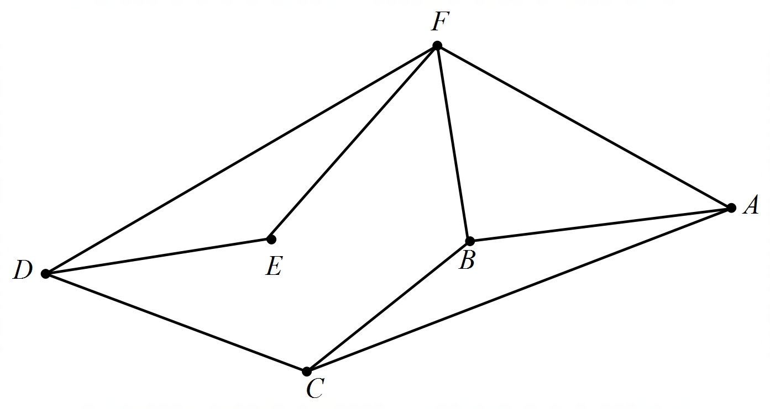

1. Set up the adjacency matrix M for the above graph (3 marks)
2. Calculate the matrix for M2 (2 marks)
3. Identify the two cells in the matrix M2 that equal zero. State clearly what this means in terms of flights between the two cities. (2 marks)
4. Also state the value of the cells in the same position in matrix M. State clearly what this means in terms of flights between the two cities. (2 marks)
5. A national newspaper has run a travel photo competition with the winning prize being a ticket for a round trip of up to a maxi mum of 3 legs between any of the locations on the above network. Note that the direction of the flight A – B – C - A and A - C - B – A are different tickets. Assuming there will be entries to the competition from all cities:
6. list the appropriate adjacency matrices used to calculate the number of tickets possible. (3 marks)
7. calculate the total number of possible trips. (2 marks)

**Question 11 (14 marks)**

Atmospheric pressure measured in kilopascals (kPa) decreases with increasing altitude above sea level. For this reason, airline cabins need to be pressurised.

|  |  |  |  |  |  |  |  |  |  |
| --- | --- | --- | --- | --- | --- | --- | --- | --- | --- |
| Altitude  (metres above Sea Level) | -1524 | -305 | 305 | 914 | 1524 | 2743 | 7620 | 13 716 | 19 812 |
| Atmospheric Pressure (kPa) | 121 | 105 | 97.7 | 90.8 | 84.3 | 72.4 | 37.6 | 14.7 | 5.6 |
| Predicted Pressure | 104.94 | ***A*** | 95.06 | 91.77 | 88.48 | 81.90 | 55.56 | ***B*** | -10.28 |
| Residual | 16.06 | 6.64 | 2.64 | -0.97 | -4.18 | -9.50 | -17.96 | ***C*** | ***D*** |

(a) (i) Determine the equation of the least-squares line for predicting Atmospheric

Pressure from Altitude stating numbers correct to 4 decimal places. (3 marks)

(ii) Use the equation from (a)(i) to determine the Predicted Pressure ***A*** and ***B*** in the table above. (2 marks)

(iii) State the *y* intercept for the least-squares line and interpret it in this context.

(2 marks)

(iv) What percentage of the variation in atmospheric pressure can be explained by the variation in altitude? (1 mark)

(b) (i) Determine the residuals ***C***and ***D*** in the table.

***C*** = __________________________

***D*** = ___________________________ (2 marks)

(ii) Hence, complete the scatter-graph of the residuals against altitude on the axes

below by plotting the last four residual values. (2 marks)

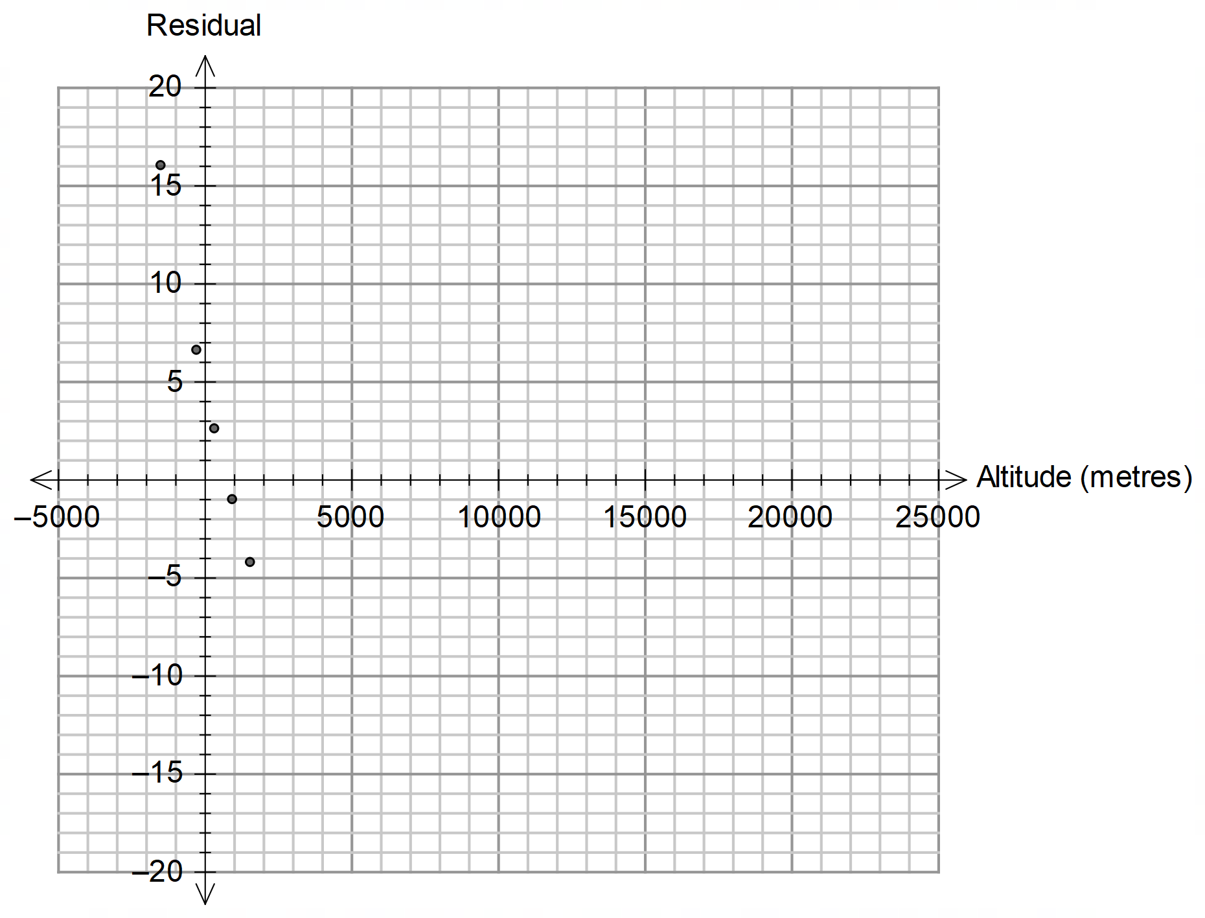

(iii) Use the residual plot to assess the appropriateness of fitting a linear model to the

data. (2 marks)

**Question 12 (12 marks)**

Long term monthly averages of weather records are shown below. The data represents 12 consecutive months for a town in Western Australia.

|  |  |  |  |  |
| --- | --- | --- | --- | --- |
| [9am relative humidity (%)](http://www.bom.gov.au/climate/cdo/about/definitions9and3.shtml#mean9amrh) | [9am temperature (°C)](http://www.bom.gov.au/climate/cdo/about/definitions9and3.shtml#mean9amtemp) | [Rainfall (mm)](http://www.bom.gov.au/climate/cdo/about/definitionsrain.shtml#meanrainfall) | [3pm temperature (°C)](http://www.bom.gov.au/climate/cdo/about/definitions9and3.shtml#mean3pmtemp) | [Maximum temperature (°C)](http://www.bom.gov.au/climate/cdo/about/definitionstemp.shtml#meanmaxtemp) |
| 45 | 23.8 | 27.4 | 32.3 | 33.7 |
| 51 | 22.8 | 31.2 | 30.9 | 32.1 |
| 54 | 21 | 25.2 | 28.6 | 29.5 |
| 60 | 17.9 | 20.5 | 24.3 | 25.3 |
| 67 | 13.9 | 24.9 | 19.9 | 20.7 |
| 74 | 11 | 27.3 | 16.8 | 17.6 |
| 73 | 9.9 | 24.2 | 16 | 16.8 |
| 65 | 11.6 | 21.3 | 17.8 | 18.7 |
| 54 | 14.8 | 13.7 | 21.3 | 22.4 |
| 47 | 17.9 | 15.8 | 24.7 | 26 |
| 45 | 20.6 | 18.7 | 27.8 | 29.1 |
| 43 | 22.7 | 16.5 | 30.7 | 32.1 |

(a) Briefly describe the relationship between the 9am relative humidity and the Maximum temperature. (No calculations are needed.) (1 mark)

Tom and Jess were interested in analysing the data to investigate the possibility of predicting the *Maximum temperature* from the other data*.*

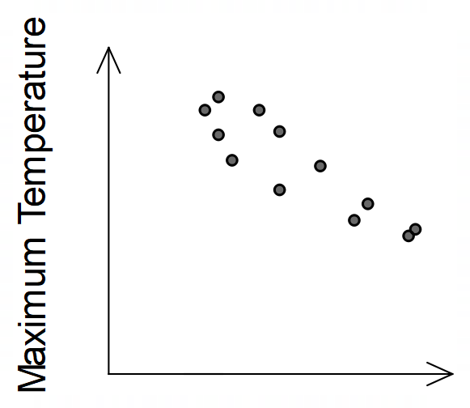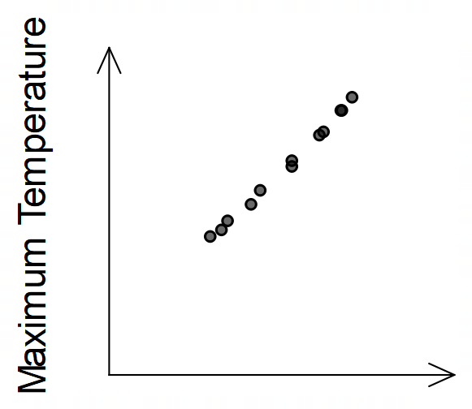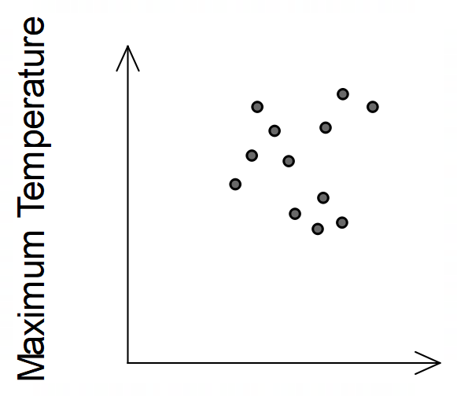(b) Tom produced the three scatter graphs below but forgot to label the horizontal axes. Insert the labels *9am relative humidity*, *9am temperature* and *Rainfall* on the appropriate graph. (2 marks)

1. (i) Jess suggested that using the 3pm temperature to predict the Maximum

temperature would likely produce a higher correlation coefficient than any of the

previous data sets.

Is this correct? Explain. (2 marks)



The equation of the least-squares line for predicting the Maximum temperature (*y*)from the 3pm temperature (*x*) is given by  and the coefficient of determination is 0.9994. Use this model to,

(ii) predict the maximum temperature for a month in which the 3pm temperature is 12 $°$ C. Comment on the reliability of this prediction. (3 marks)

(iii) state the correlation coefficient and describe the association between 3pm temperature and Maximum temperature in terms of its direction and strength.

(2 marks)

(iv) determine the expected difference in the monthly Maximum for two months in which the 3pm temperatures differ by 15 $°$ C, accurate to 1 decimal place (2 marks)

**Question 13 (6 marks)**

The graph below represents a local electricity power grid. The nodes represent substations and the edges represent the high-tension power lines that connect them.

An engineer wishes to visit **all the substations** for maintenance purposes, but it is not her job to check the power lines. She wishes to start and finish as close to home without having to cover unnecessary ground.

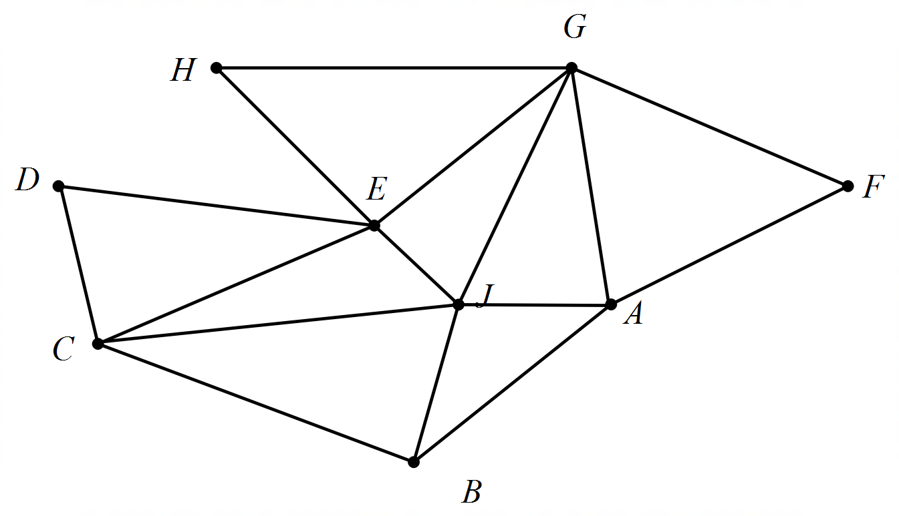

1. Set out an appropriate journey naming all the substations she would visit in the correct order given she would start at substation G. (2 marks)
2. Which of the substations did she not travel **between** on this journey? (2 marks)

A colleague must replace the engineer from part (a) and wishes to leave from substation C to cover the same cycle.

1. List the new order of the substations that the second engineer would take. (2 marks)

**Question 14 (7 marks)**

Consider an A0 sheet of paper. You may assume that it has an area of 1 m2.

Sizes A1, A2, A3, …. have an area that reduces by half. For example, A1 is one-half of A0 and A2 is one-half of A1, etc. These form a sequence where;



1. State the first 3 terms of the sequence. (1 mark)

(b) State a recursive rule for determining of the sequence (2 marks)

1. A stationary provider has one sheet of each of the different paper sizes A0 to A*n* in sequence (where *n* is a counting number). She spreads each sheet out and determines that all the sheets cover a total area of just over 1.99 m2. How many sheets did she have in stock and what was the size of the smallest sheet? (4 marks)

**Question 15 (8 marks)**

(a) A group of six friends each support different Australian league clubs as shown in the top row of the table below. They are interested to list which clubs played in the Asian football competition in the last few years.

A “” in a given cell indicates that the club has played in that year and a “**X**” indicates that the team did not play in the competition that year

|  |  |  |  |  |  |  |  |  |
| --- | --- | --- | --- | --- | --- | --- | --- | --- |
|  | Adelaide United | Brisbane Roar | Mariners | Melbourne Victory | Newcastle | Perth Glory | Sydney FC | Western Sydney |
| 2020 | **X** | **X** | **X** | Checkmark | **X** | Checkmark | Checkmark | **X** |
| 2019 | **X** | **X** | **X** | Checkmark | Checkmark | **X** | Checkmark | **X** |
| 2018 | **X** | Checkmark | **X** | Checkmark | **X** | **X** | Checkmark | **X** |
| 2017 | Checkmark | Checkmark | **X** | **X** | **X** | **X** | **X** | Checkmark |
| 2016 | Checkmark | **X** | **X** | Checkmark | **X** | **X** | Checkmark | **X** |
| 2015 | **X** | Checkmark | Checkmark | **X** | **X** | **X** | **X** | Checkmark |
| 2014 | **X** | **X** | Checkmark | Checkmark | **X** | **X** | **X** | Checkmark |

1. Display this information as a bipartite graph, clearly showing which clubs played in Asia and when. (4 marks)

1. From the table which club qualified the most over that seven-year period? (1 mark)

1. If the current A League was to play 110 matches on a home and away basis, that is each team plays all other teams twice, how many teams would make up the competition? Show your working. (3 marks)

**Question 16 (8 marks)**

Orienteering is a sport which combines cross-country running and map reading. In this sport the runners consider whether the terrain is flat or hilly and other conditions and not just the distance between points. When they race between two check points there are no restrictions as to which path to take but there are a number of check points where a runner must stamp, in this case a minimum of three.

A race is staged in a local national park between points A and K and a contestant has determined, from experience, how long **in minutes** each of these legs should take him to run. He has drawn a network, shown below, of his times between the various check points.

1. Use the “Shortest distance” algorithm on the network below to determine the runner’s minimum time and which check points he/she will pass through. (4 marks)

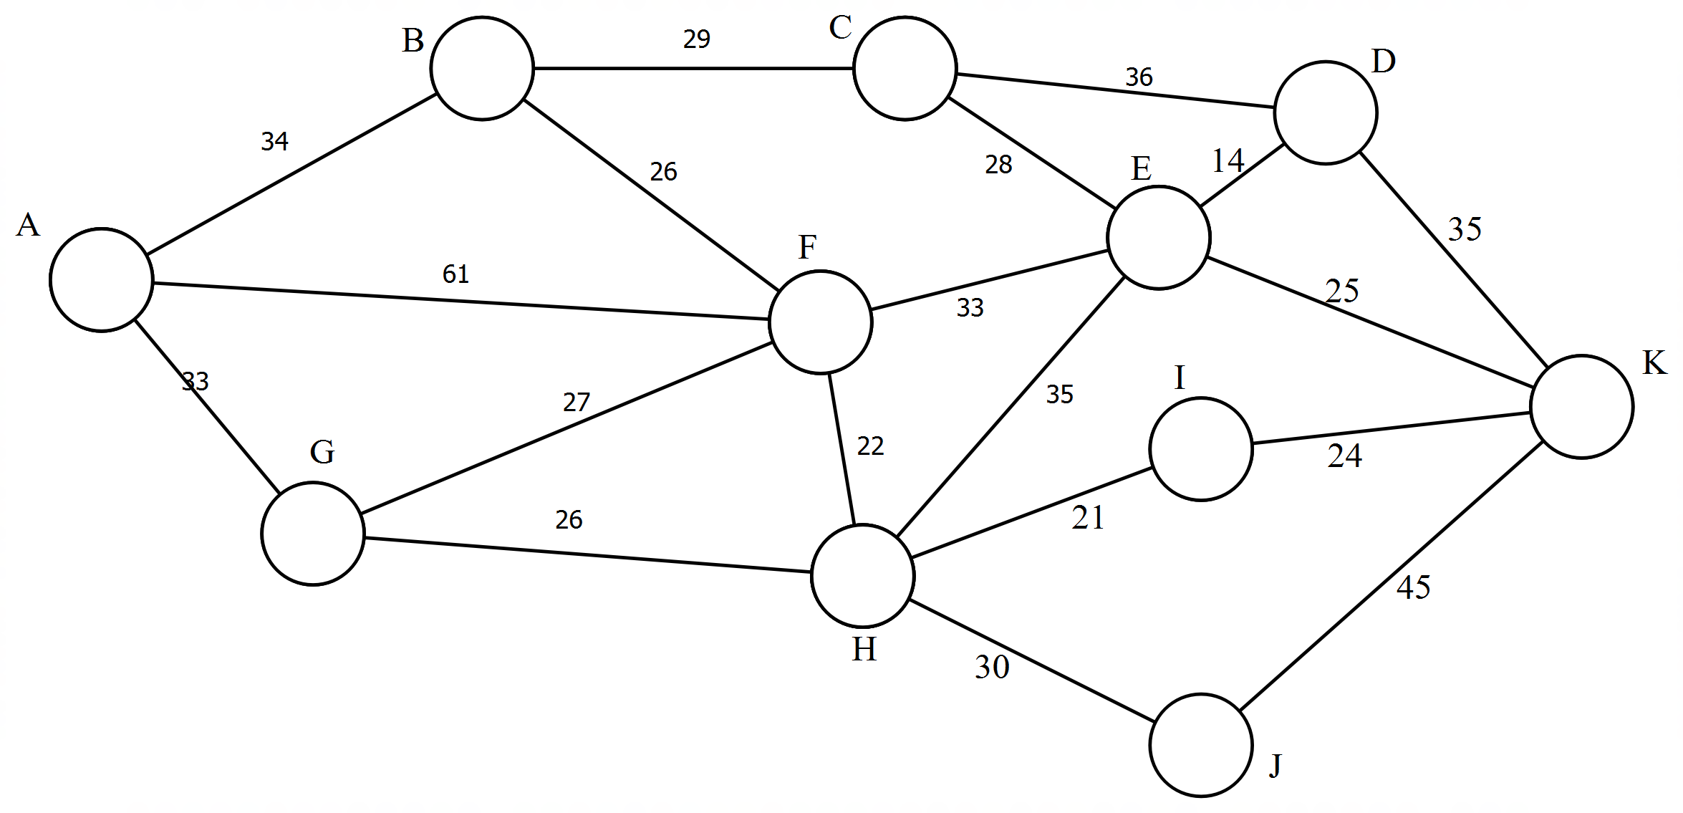

(b) Given there is a bonus of 20 minutes reduction off the runner’s time if he/she uses check point F and noting that a minimum of three checks are required.

1. Complete a modified path on the diagram below to check for the shortest time if the runner was to go for the bonus. (2 marks)

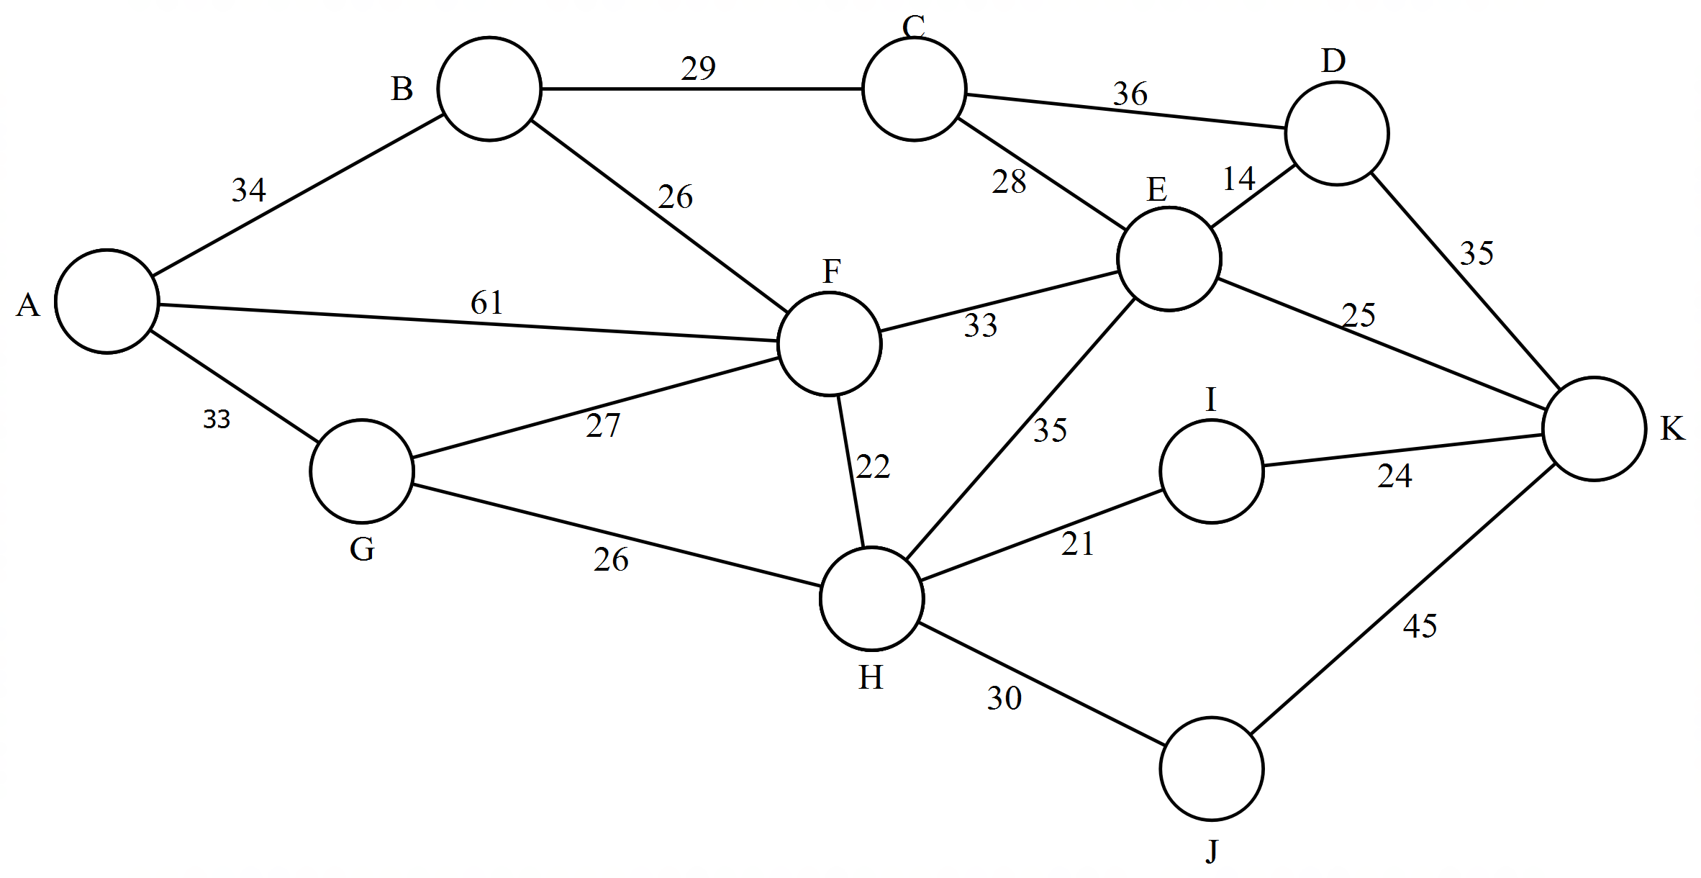

1. State the modified path from A to K and its new time. (2 marks)

**Question 17 (11 marks)**

Mark and Julie inherited a block of land from their Grandparents and decided to build a dwelling on the property for rental purposes.

For taxation purposes, they are allowed 2.5% pa fixed rate depreciation on the initial cost of construction ($160 000) of the house. In addition, they select the **diminishing value method** of depreciation, for the following items:

|  |  |  |
| --- | --- | --- |
| Items | Value | Depreciation rate pa |
| Carpets and floor coverings | $9500 | 10% |
| Hot water system | $2000 | 12% |
| Light fittings and window treatments | $7500 | 15% |
| Airconditioning system | $6500 | 20% |

(a) What is the depreciation amount per year, on the construction cost? (1 mark)

(b) Complete the table below by calculating the depreciation amount allowed for each of the items for the first two years after construction. (4 marks)

|  |  |  |  |  |
| --- | --- | --- | --- | --- |
| Items | Original Value | Depreciation rate pa | Depreciation in 1st year | Depreciation in 2nd year |
| Carpets and floor coverings | $9500 | 10% |  | $855 |
| Hot water system | $2000 | 12% | $240 | $211.20 |
| Light fittings and window treatments | $7500 | 15% |  |  |
| Airconditioning system | $6500 | 20% | $1300 |  |

(c) Determine the amount of depreciation that will be allowed for Light fittings and window treatments in the tenth year of renting the property. (2 marks)

**End of Questions**

Additional working space

Question number: __________________

Additional working space

Question number: __________________

Additional working space

Question number: __________________

**Acknowledgements**

Question 8 Data source: Royal Life Saving Society of Western Australia.

*Bigger, Better, Safer: A report of the Western Australian Aquatics Industry 2012-13*. Retrieved 17th February 2020 from

<https://royallifesavingwa.com.au/-/media/files/rlsswa/research>

Question 9 Data source: Australian Government, Bureau of Meteorology.

Climate statistics for Australian locations.

Retrieved 17th February 2020 from

<http://www.bom.gov.au/climate/averages/tables/cw_012038.shtml>

Question 10 Data source: MIDE Engineering Solutions

. Relationship between Altitude and Pressure

Retrieved 17th February 2020 from

<https://www.mide.com/air-pressure-at-altitude-calculator>

Question14 https://en.wikipedia.org/wiki/Australian_clubs_in_the_AFC_Champions..._

Records of the Australian A-League clubs in the AFC Champions League.

© MAWA, 2020

This examination is Copyright but may be freely used within the school that purchases this licence.

* The items that are contained in this examination are to be used solely in the school for which they are purchased.
* They are not to be shared in any manner with a school which has not purchased their own licence.
* The items and the solutions/marking keys are to be kept confidentially and not copied or made available to anyone who is not a teacher at the school. Teachers may give feedback to students in the form of showing them how the work is marked but students are not to retain a copy of the paper or marking guide until the agreed release date stipulated in the purchasing agreement/licence.

*Published by The Mathematical Association of WA*

*12 Cobbler Place, MIRRABOOKA 6061.*